**Project Design Phase-II**

**Technology Stack (Architecture & Stack)**

|  |  |
| --- | --- |
| Date | 03 October 2022 |
| Team ID | PNT2022TMID015175 |
| Project Name | Project – Skill and Job Recommender |
| Maximum Marks | 4 Marks |

**Technical Architecture:**

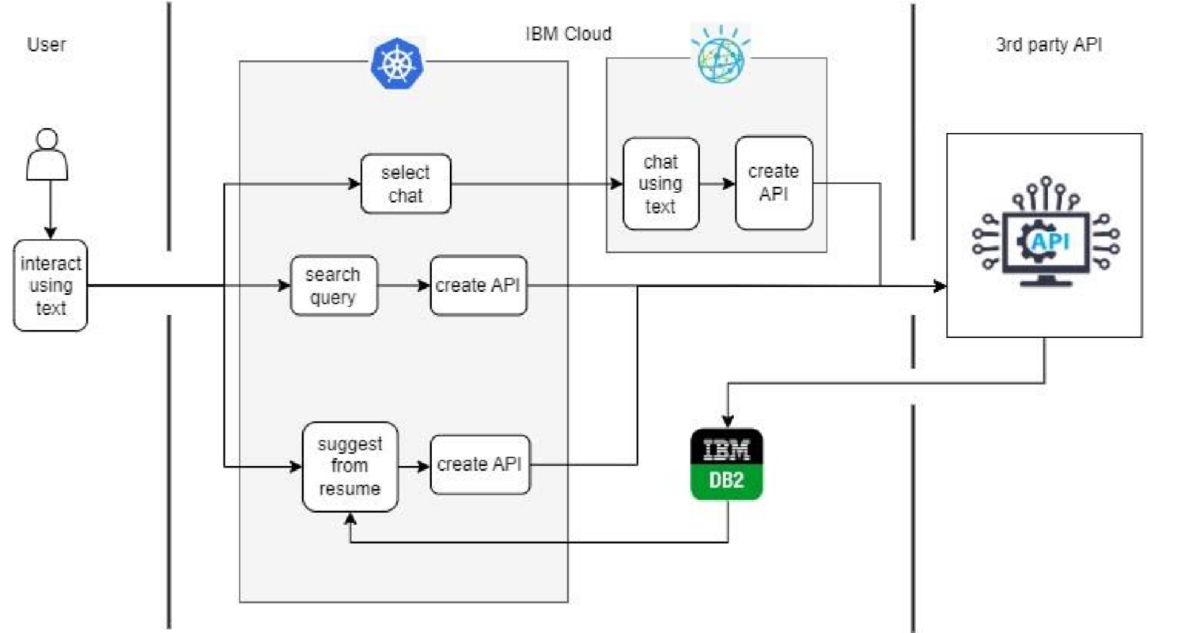

**Table-1 : Components & Technologies:**

|  |  |  |  |
| --- | --- | --- | --- |
| **S.No** | **Component** | **Description** | **Technology** |
| 1. | User Interface | How user interacts with application e.g. Web UI, Mobile App, Chatbot etc. | HTML, CSS, JavaScript, Flask |
| 2. | Application Logic-1 | Using ChatBot | IBM Watson Assistant |
| 3. | Application Logic-2 | Using Search query | Flask |
| 4. | Application Logic-3 | Using Resume uploaded | Flask |
| 5. | Database | Data Type, Configurations etc. | NoSQL. |
| 6. | Cloud Database | Database Service on Cloud | IBM DB2. |
| 7. | File Storage | File storage requirements | IBM Block Storage |
| 8. | External API-1 | Purpose of External API used in the application | Job recommender API |
| 9. | Infrastructure (Server / Cloud) | Application Deployment on Local System / Cloud Local Server Configuration:  Cloud Server Configuration : | Kubernetes |

**Table-2: Application Characteristics:**

|  |  |  |  |
| --- | --- | --- | --- |
| **S.No** | **Characteristics** | **Description** | **Technology** |
| 1. | Open-Source Frameworks | List the open-source frameworks used | Flask, IBM Cloud |
| 2. | Security Implementations | List all the security / access controls implemented, use of firewalls etc. | SHA-256, Encryptions, IAM Controls, OWASP |
| 3. | Scalable Architecture | scalability of architecture | Kubernetes |
| 4. | Availability | availability of application | Kubernetes |
| 5. | Performance | Design consideration for the performance of the application (number of requests per sec, use of Cache, use of CDN’s) etc. | IBM Cloud APM |